The Islamia University of Bahawalpur
Department of Information Technology
Faculty of Computing



Software Requirement Specification (SRS)
for

Complaint Management System

Version 1.0

By
Muhammad Yasir Hameed
S23BINFT1M01131
Session Spring 2023 – 2027
Supervisor
Dr Rana Nazir Ahmad
Bachelor of Science in Information Technology

Revision History

Name | Date | Reason for changes | Version
M Yasir Hameed | 30/04/2026 | Some Modification in SRS like header and other issues | 1.0

Document Approval
The following Software Requirements Specification has been accepted and approved by the following:
Signature | Printed Name | Title | Date

Application Evaluation History

Comments (by committee)  *include the ones given at scope time both in doc and presentation | Action Taken

Supervised by
Dr Rana Nazir Ahmad
Signature

Table of Contents

1. Introduction 1
1.1 Purpose 1
1.2 Scope 1
1.3 Definitions, Acronyms, and Abbreviations. 1
1.4 References 1
1.5 Overview 1
2. The Overall Description 2
2.1 Product Perspective 2
2.1.1 Operations 2
2.1.2 Site Adaptation Requirements 3
2.2 Product Functions 3
2.3 User Characteristics 3
2.4 General Constraints 4
2.5 Assumptions and Dependencies 4
3. Specific Requirements 4
3.1 External Interface Requirements 5
3.1.1 System Interfaces 5
3.1.2 Interfaces 5
3.1.3 Hardware Interfaces 5
3.1.4 Software Interfaces 5
3.1.5 Communications Interfaces 6
3.2 Functional Requirements 6
3.2.1 <Functional Requirement or Feature #1> 6
3.2.2 <Functional Requirement or Feature #2> 7
3.3 Use Cases 7
3.3.1 Use Case #1 7
3.3.2 Use Case #2 7
3.4 Classes / Objects 7
3.4.1 <Class / Object #1> 7
3.4.2 <Class / Object #2> 7
3.5 Non-Functional Requirements 7
3.5.1 Performance 8
3.5.2 Reliability 8
3.5.3 Availability 8
3.5.4 Security 8
3.5.5 Maintainability 8
3.5.6 Portability 8
3.6 Inverse Requirements 8
3.7 Logical Database Requirements 8
3.8 Design Constraints 8
3.8.1 Standards Compliance 8
4. Analysis Models 9
4.1 Sequence Diagrams 9
4.2 Data Flow Diagrams (DFD) 9
4.3 State-Transition Diagrams (STD) 9
5. Supporting Information 9
Appendix A – Background Research on: 9
Appendix B – Data Dictionary 9

1. Introduction
Complaint Management System is a app-based application made entirely using JAVA . The system is designed for educational institutions and organizations to monitor online complaints in efficient and organized manner. The purpose of this system is to make the process faster and automate the manual procedure currently in place.

Purpose
The purpose of this system is to streamline the process of submitting, tracking and dealing with complaints by automating the process in order to save time and reduce paperwork.

Scope
Complaints Management System is a app based system for solving and tracking complains online. Users like students, employees and staff can lodge complains online and track the status of their complain at any time. Administrators can update status and resolve complains online. This is useful for schools, colleges, universities and many other organizations. Automated system replacing the manual process for efficient complaints management.

1.3 Definitions, Acronyms, and Abbreviations.
Term / Acronym | Full Form / Definition
SRS | Software Requirements Specification; a document describing the system’s functional and non-functional requirements and the constraints under which it must operate.
Complaint Management System | A mobile-based system developed using Android Studio and Java that allows users to submit, track, and manage complaints electronically.
Android Studio | The official integrated development environment (IDE) used to develop the mobile complaint monitoring application.
Java | A programming language used to implement the Android application’s logic and functionality.
SQLite | A lightweight relational database embedded in Android apps, used to store complaints, user data, and system records.
Mobile Application | A software application designed to run on Android devices, accessed through the app interface.
Complaint | A report submitted by a user (e.g., student, employee, or staff) about an issue that requires resolution.
User | A person who submits and tracks complaints via the mobile application.
Admin | An authorized user responsible for managing complaints, monitoring users, and overseeing system operations.
Dashboard | The app interface for admins that displays summaries of complaints, their statuses, and other relevant metrics.
Database | A structured collection of data (using SQLite) storing user details, complaints, and status records.
Authentication | The process of verifying the identity of a user attempting to log in to the app.
Authorization | The process of granting users permission to access specific features or sections of the app.
Status Tracking | The ability to monitor the progress of a complaint, e.g., pending, in process, or resolved.
Performance | The system’s efficiency in responding to user actions and handling multiple requests simultaneously.
Security | Measures implemented to protect user data, complaint records, and app functionality from unauthorized access or misuse.
Term / Acronym | Full Form / Definition

Table 1: Glossary of Terms and Acronyms for the Complaint Management System

1.4 References
No. | Document Title | Report No. / Version | Date | Publishing Organization | Source
1 | IEEE Standard for Software Requirements Specification | IEEE 830-1998 | 1998 | IEEE | https://standards.ieee.org
2 | ISO/IEC/IEEE Systems and Software Engineering — Life Cycle Processes | ISO/IEC/IEEE 12207 | 2017 | ISO / IEEE | https://www.iso.org
3 | PHP Official Documentation | PHP 8.x | Latest | PHP Group | https://www.php.net/docs.php
4 | MySQL Database Documentation | MySQL 8.x | Latest | Oracle Corporation | https://dev.mysql.com/doc/
5 | HTML Living Standard | HTML5 | Latest | WHATWG | https://html.spec.whatwg.org
6 | CSS Specifications | CSS3 | Latest | W3C | https://www.w3.org/Style/CSS/
7 | app-Based Complaint Management Systems (Concept & Practices) | N/A | Various | Research Articles / Case Studies | https://scholar.google.com

Table 2: List of References and Standards for the Complaint Management System

1.5 Overview
Software Requirements Specification for Complaint Management System using PHP and MySQL. This Software Requirements Specification (SRS) document provides a clear and comprehensive description of Complaint Management System to be developed. It describes the whole system in terms of features provided to user. It describes how different components interact with each other. The document is meant for the developers, project managers and stakeholders of system to clearly understand its features and limitations. It covers system perspectives, user characteristics, product functions and restrictions. It is a guide for the developers to develop system that meets requirements of users. It will serve as a reference for maintenance and enhancement of the system after deployment.

2. The Overall Description
The Complaint Management System is a app-based application which is designed for online complaint handling in any organizations. The system provides automated online complaint registration and online complaint tracking features which enables users to lodge a complaint anytime, anywhere online. The system provides an effective complaint management platform where administrators can monitor and process complaints effectively. This website content explains briefly on the overall system functionality, operation environment, key features, user interaction and system purposes.

2.1 Product Perspective
Complaint Management System (OCMS) is completely independent system for monitoring and managing complaints. It can be integrated with existing platform. Complaint Management System is developed using PHP for server side scripting and MySQL for database management. System would work on any web server and it would be accessible via web browsers. System has interface for both complainant/users as well as administrators of the system. System interacts with database to store and retrieve data for the complaints managed using system. Future requirements can be easily met as it is a dynamic system. Configuration for mobile based application and email integration can also be done.

2.1.1 Operations
The system is accessed through a simple app interface, where users can register or login and send complaints. All complaints are stored in the system’s database, and are marked with status such as pending, in progress or resolved. The administrator can monitor, edit and manage all complaints through the dedicated admin dashboard. Users will also receive notifications on status change. The system is designed to handle data in proper manner, validate it and store it safely. It can handle multiple users at same time and maintains data history for future reference. The system is designed to be very simple, efficient and accessible 24/7 over internet.

2.1.2 Site Adaptation Requirements
First we need to mention that your web hosting server must have the web server software (I.E. IIS), and the PHP Software to run the system properly, it would be recommended to host it on a reliable server, The System can be compatible with any of the Browsers like (Chrome, Firefox, Edge…etc.) And minimum equipment needed to run it is just a computer or smartphone that has an internet access. The System allows users to modify and tailor it according to the needs of their Organization whether it is for adding different complaint categories or different user groups. Furthermore, the System must be equipped with the most advanced security to ensure secure login and protection of data in the System, in addition to the System’s capability to back-up and recover data.

2.2 Product Functions
The Complaint Management System contains several important functions, such as user registration, user login, submit complaints and track complaints. Users will be able to record complaints and follow up on the progress of the complaint through the entries recorded by administrators. Administrators are able to record, rank and update complaints managed by them. The system also can store all the records of the complaints for analysis, etc. The system also equipped with search, filtering and reporting feature. The purpose of the online system is to support smooth communication and to follow up complaints efficiently and transparently.

2.3 User Characteristics
This system is designed to be easy enough for a layman with minimal computer and internet skills to be able to use. The target user could be a student, employee, faculty/staff, etc. They need to be able to navigate around to app applications, register for a user account and submit a complaint. The administrators will have a slightly higher level of technical knowledge to be able to run the system, update the status of complaints and to manage the user accounts. The system will have a simple interface to enable users of any skill level to easily use the system. Minimal training will be needed because the system functions like any standard web application. The system is also accessible to virtually anyone with any disability.

2.4 General Constraints
The system is constrained by a number of technological, security and operational limitations. The system relies on the internet for both access and operation. As such, the system must also comply with data protection and privacy regulations to ensure users' details are safeguarded. Furthermore, there are performance limitations placed on the system - it must be able to cope with the simultaneous use of multiple users without undue delay. As with any system, there are limitations placed upon it by the capacity and performance of the server and database it will be hosted on. The system and interface must also be designed and built within a fixed budget and timescale. Finally, it is imperative to ensure that the system can be accessed via a number of web-browsers and devices.

2.5 Assumptions and Dependencies
We assume you have internet and basic knowledge of web applications. We assume you have a stable environment on a server and that PHP and MySQL are installed and running. We expect administrators to respond to user complaints in a timely fashion and administer the system in a correct and logical manner. The system is also dependent on external software such as a web server (we use Apache) and a database system (we use MySQL). The system's performance will also be affected by how accurately you enter your data. We are unable to guarantee correct performance of the system where factors such as server performance, network connectivity and database performance are involved. Regular maintenance and updates on the software will be required for optimal performance.

3. Specific Requirements

3.1 External Interface Requirements
This project requires the development of an Complaint Management System that should have a web based interface that can run on Desktops/Laptops/Smartphones using standard web browsers (Chrome/Firefox/Edge). The users should be able to login using their username and password to submit/complain/monitor/reply complaints. The system should have integration with MySQL database to store user information and all the submitted complains. It should also be able to send email updates. The interface should be user friendly, responsive and accessible to cater to the needs of students, employees and staff with minimal training.

3.1.1 System Interfaces

No. | External System / Device | Functionality Supported | Interface Description
1 | Web Browser | Provides user access to the system for browsing services, managing campaigns, and viewing reports | Supports modern browsers (Chrome, Firefox, Edge, Safari) via HTTPS. All pages are responsive and secure.
2 | Display / Management Dashboard | Displays real-time campaign analytics, notifications, and reports to users and administrators | Outputs processed data via app GUI dashboards and charts using HTML, CSS, and JavaScript.
3 | Database / Data Storage | Stores user accounts, campaign data, service configurations, and logs | Reads/writes to MySQL or compatible databases using SQL queries with secure authentication and backup support.
4 | Optional Analytics / Reporting Tools | Sends campaign or user data for external reporting, analytics, or integration with third-party tools | Transmits data via secure RESTful APIs in JSON format with authentication and encryption.
5 | Web Server / Hosting Environment | Provides runtime environment for executing PHP scripts, handling requests, and managing resources | Requires a compatible web server (Apache, Nginx) with PHP, MySQL, and proper OS services for threading, file access, and network communication.
6 | Notification / Messaging Services (Optional) | Sends alerts or notifications for campaign milestones, deadlines, or performance thresholds | Interfaces with email (SMTP) or messaging APIs (Twilio, Push notifications) to deliver real-time updates to users.

Table 3: External Interface Specifications and System Interdependencies

3.1.2 Interfaces
The user interface of the Complaint Management System is made simple, intuitive and user-friendly for easier navigation for students, employees and staff. Icons, headings and colors are used to highlight important elements to avoid mistakes and to assist users in navigating properly. The system has simple menus, forms and tabs for student’s complaint submission and tracking. The interaction with the system does not require any additional training for students, employees and staff. The admin interface comes with more options to manage complaints, users and generate reports.

3.1.3 Hardware Interfaces
The system is designed to be as user friendly as possible. You can go to any page you wish, lodge or track a complaint and generally get around the system without too much trouble. Helpful instructions and feedback messages are provided wherever necessary and the interface has been designed to be as user friendly and error free as possible.

3.1.4 Software Interfaces
Our system is fully responsive and can be accessed via Desktop, Tablet and Smart Phone with content and layout automatically adjusting to suit the screen size of the user. This means our system can be accessed at anytime and anywhere. You can access our system using your smart phone, tablet, computer and notebook with ease.
No. | Name | Mnemonic | Specification / Doc No. | Version | Source
1 | PHP | PHP | PHP Language Reference | 8.x+ | PHP Group (https://www.php.net)
2 | MySQL | SQL | MySQL Reference Manual | 8.x | Oracle Corporation (https://dev.mysql.com/doc/)
3 | HTML / CSS / JavaScript | HTML/CSS/JS | W3C Specifications | Latest | W3C (https://www.w3.org)
4 | Optional Messaging API | MSG | Vendor API Documentation | Latest | Twilio / SMTP Server (https://www.twilio.com)
5 | Optional Analytics / Reporting Libraries | LIB | Library Documentation | Latest | Chart.js, Google Charts, or similar (https://www.chartjs.org)
Table 4: Software Languages, Libraries, and Technical Specifications

3.2 Functional Requirements
This section describes specific features of the software project. If desired, some requirements may be specified in the use-case format and listed in the Use Cases Section.
Subsection | Description
3.2.1.1 Introduction | This function allows users to submit, track, and manage complaints online. It ensures that all user interactions, complaint submissions, and responses are handled efficiently and securely through a app interface.
3.2.1.2 Inputs | Complaint details submitted via web forms, dropdowns, or API calls. User credentials, complaint categories, and optional attachments or supporting documents.
3.2.1.3 Processing | User inputs are validated, processed, and stored in the database. Complaint handling operations, status updates, and administrator responses are executed server-side using PHP and SQL queries. Notifications or alerts are generated based on complaint status changes or deadlines.
3.2.1.4 Outputs | Confirmation messages, updated complaint status, dashboards, and reports displayed on the GUI. Optional notifications sent via email, SMS, or push services to keep users informed.
3.2.1.5 Error Handling | Invalid input, missing fields, or server/database errors trigger error messages displayed to users. All errors are logged for review and corrective action by administrators.

User Registration
Subsection | Description
3.2.2.1 Introduction | Allows new users (students, staff, employees) to create an account and access the complaint system securely.
3.2.2.2 Inputs | User name, email, password, department, and role selection submitted via registration form.
3.2.2.3 Processing | Inputs are validated for correctness and uniqueness. Passwords are hashed, and user details are stored in the database. Confirmation email may be sent.
3.2.2.4 Outputs | Account creation confirmation message, login access, and email verification notification (if applicable).
3.2.2.5 Error Handling | Duplicate email, weak password, or missing required fields trigger error messages. Errors are logged for admin review.

Complaint Submition
Subsection | Description
3.2.3.1 Introduction | Enables users to submit complaints online with relevant details and attachments.
3.2.3.2 Inputs | Complaint title, category, description, attachments (optional), user credentials.
3.2.3.3 Processing | Inputs are validated, stored in the database, and assigned a unique complaint ID. Notifications sent to the relevant administrator.
3.2.3.4 Outputs | Confirmation message with complaint ID, updated user dashboard showing submitted complaint.
3.2.3.5 Error Handling | Missing mandatory fields, invalid attachments, or server/database errors trigger error messages and are logged.

Complaint Tracking
Subsection | Description
3.2.4.1 Introduction | Allows users and staff to track the status of submitted complaints in real-time.
3.2.4.2 Inputs | Complaint ID, user login credentials.
3.2.4.3 Processing | System retrieves complaint details from the database and calculates current status. Generates notifications for updates if applicable.
3.2.4.4 Outputs | Dashboard view showing complaint status, history of actions, and administrator responses. Optional notifications sent to user.
3.2.4.5 Error Handling | Invalid complaint ID, unauthorized access, or database errors trigger user-friendly error messages and logs.

Admin Complaint Management
Subsection | Description
3.2.5.1 Introduction | Enables administrators to view, assign, respond to, and resolve complaints efficiently.
3.2.5.2 Inputs | Complaint ID, assignment details, response notes, status updates.
3.2.5.3 Processing | Validates admin actions, updates complaint status in database, logs activity, and triggers notifications for users.
3.2.5.4 Outputs | Updated complaint status, user notifications, and admin dashboard reflecting current workload and complaint metrics.
3.2.5.5 Error Handling | Invalid actions, database failures, or missing inputs trigger error messages and are logged for auditing.

3.3 Use Cases
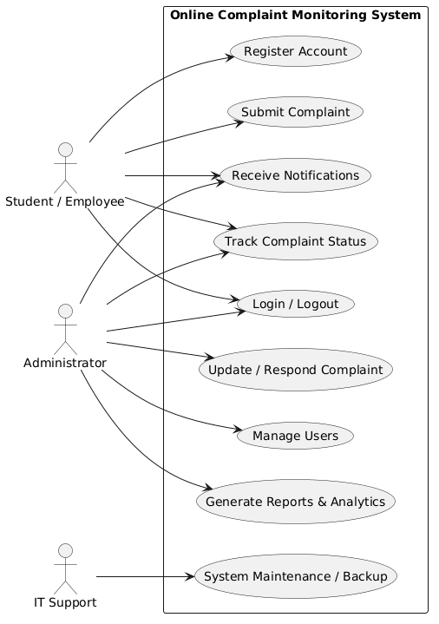

Figure 1 Use Case Diagram Complaints Management System

3.4 Classes / Objects
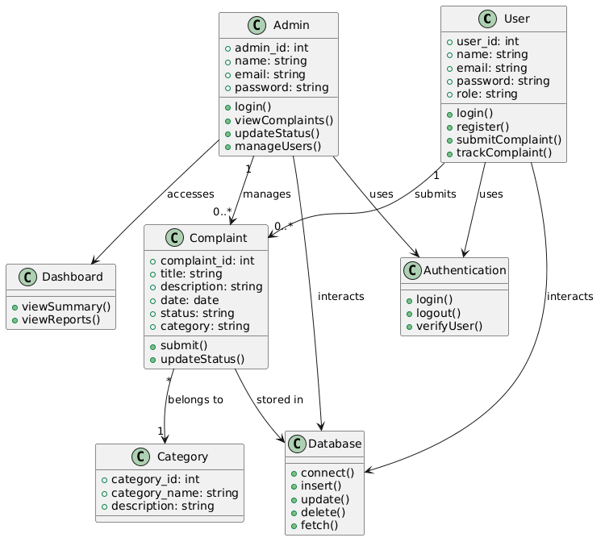
Figure 2 Class Diagram Complaints Management System

3.5 Non-Functional Requirements
Non-functional requirements define the system-wide characteristics that the Digital Marketting Services must satisfy. These requirements focus on quality attributes such as performance, reliability, usability, security, and maintainability.

3.5 Non-Functional Requirements

3.5.1 Performance
The system shall process user requests and load dashboard data within 2 seconds
Reports and analytics shall update in real-time, with a maximum delay of 1 second from user action to displayed result.
The system shall support at least 50 simultaneous user sessions without performance degradation.

3.5.2 Reliability
The system shall achieve 99% uptime during operational hours.
The system shall be capable of recovering from server or software crashes within 1 minute, restoring previous configuration and campaign data automatically.
The mean time between failures (MTBF) shall exceed 30 days of continuous operation under normal usage conditions.

3.5.3 Usability
Users shall be able to create, configure, and manage campaigns within 5 minutes of first use without prior training.
The GUI shall provide clear visual indicators for service status, campaign progress, and notifications to minimize user errors.
The system shall support users with limited technical experience, with menu options, labels, and workflows understandable without specialized knowledge.

3.5.4 Security
The system shall restrict access to configuration settings, campaign management, and database data to authorized users only.
All stored logs, reports, and database records shall be protected from unauthorized modification.
Communication with external services (email, APIs, payment gateways) shall use encrypted channels (HTTPS/SSL) wherever applicable.

3.5.5 Maintainability
The system shall allow configuration changes (e.g., service preferences, campaign settings, notification options) without requiring a server restart.
Updates to core system components, dashboards, or libraries shall be installable without data loss or manual reconfiguration.

3.5.6 Portability
The system shall run on customer-specified web hosting environments supporting PHP, MySQL, and modern browsers with minimal setup.
Required third-party libraries (PHP, JavaScript frameworks, Charting libraries) shall be compatible with the specified hosting environment and server software

3.7 Logical Database Requirements
Entity | Description | Key Attributes | Frequency of Use | Access Capabilities
User | Stores information about registered users of the system | userID, name, email, password, role, registrationDate | Medium (login, profile updates) | Read/Write by admin; Read/Write by user for own account
Complaint | Stores details of complaints submitted by users | complaintID, userID, title, category, description, attachments, status, submissionDate, resolutionDate | High (during complaint submission, tracking, and updates) | Read/Write by user for own complaints; Read/Write by admin for all complaints
Response | Stores administrator responses to complaints | responseID, complaintID, adminID, responseText, responseDate | Medium (when complaints are addressed) | Read/Write by admin; Read by user for own complaint
Notifications / Alerts | Stores messages sent to users about complaint status updates | alertID, userID, complaintID, timestamp, eventType, message | Medium (when complaint status changes) | Write by system; Read by user/admin
System Configuration | Stores operational and system settings | configID, userID, preferences, thresholds | Low (only when settings are modified) | Read/Write by admin; Read by system
Entity | Description | Key Attributes | Frequency of Use | Access Capabilities

Table 5: Data Entity Descriptions and Access Control Specifications

4. Analysis Models
Several analysis models have been developed to provide a clear understanding of the functional and non-functional requirements of the Complaint Management Systems system and to support traceability throughout the SRS. These models include use case diagrams, class diagrams, sequence diagrams, entity-relationship (ER) diagrams, and state transition diagrams.
- The use case diagram identifies interactions between external actors, such as users, administrators, and external services (e.g., email, analytics APIs), with the system, providing a visual representation of all primary functionalities, including service browsing, campaign management, user management, reporting, notifications, and system configuration.
- The class diagram captures the static structure of the system, showing major classes such as SystemController, User, Campaign, ServiceManager, Analytics, NotificationManager, and Logger, along with their relationships. This allows developers to trace each class to the functional requirements it supports.
- Sequence diagrams illustrate the flow of operations for critical functions, such as creating campaigns, updating analytics, sending notifications, or generating reports, showing the order of interactions between classes and external entities.
- The ER diagram represents the logical data model, identifying data entities, attributes, and relationships for users, campaigns, services, metrics, and alerts, providing a foundation for database design and ensuring traceability to data storage and retrieval requirements.
- State transition diagrams model the dynamic behavior of key system components, such as campaign states (draft, active, completed) and notification sequences, ensuring all possible system states and transitions are accounted for in functional requirements.
Together, these analysis models form a comprehensive framework that supports the derivation, validation, and traceability of all requirements documented in this SRS, providing developers and stakeholders with a clear understanding of system behavior, interactions, and expected operations.

4.1 Sequence Diagrams
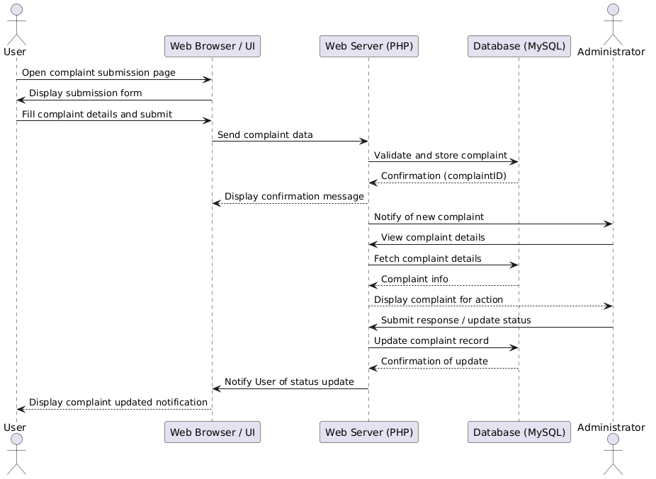
Figure 3 Sequence Diagram Complaints Management System

4.2 Data Flow Diagrams (DFD)

Level 0
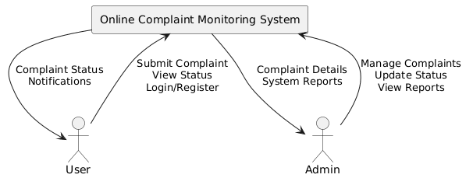
Figure 4 Data Flow Diagram 0 Level

DFD 1

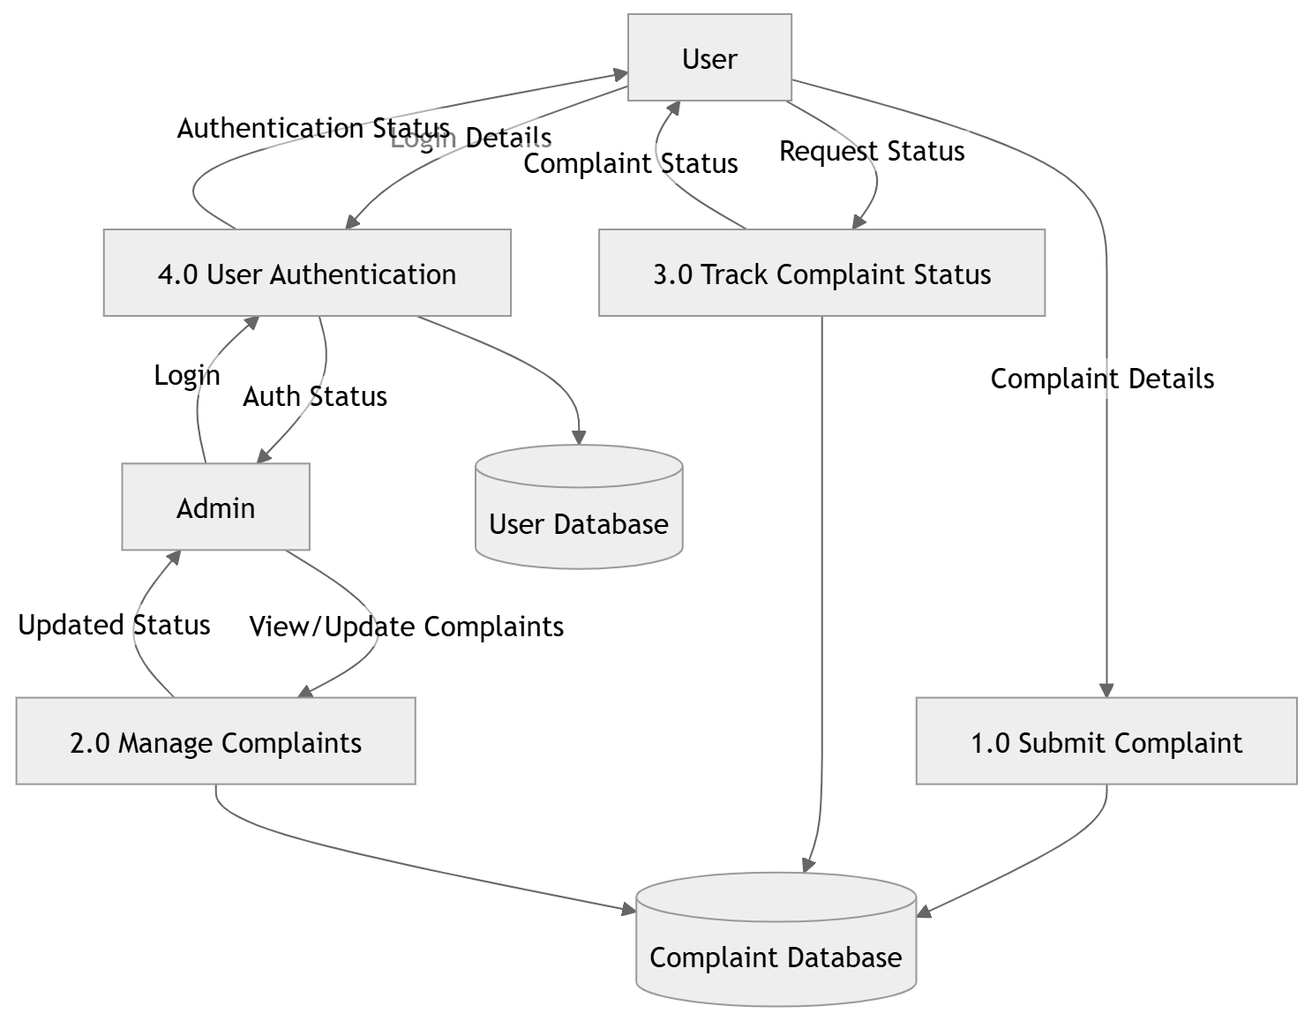
Figure 5 Dataflow Diagram Level 1 Complaints Management System

DFD Level 2
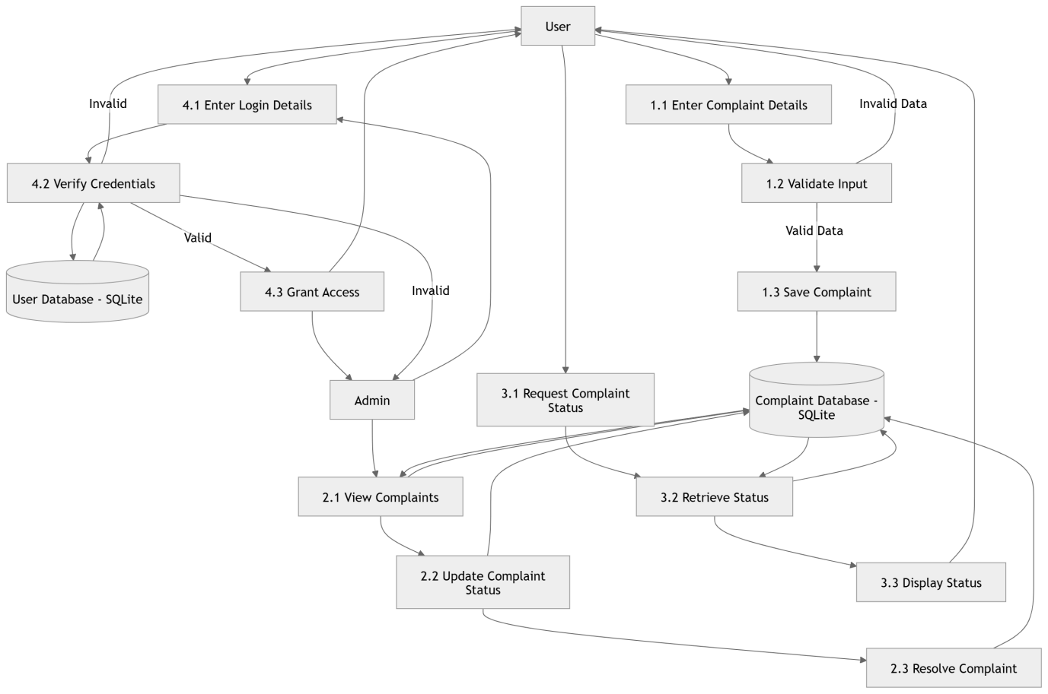
Figure 6 Dataflow Diagram Level 2 Complaints Management System

5. Supporting Information
Complaint Management System is a software which provides a web enabled platform to all organizations like schools, colleges, universities etc. to monitor online complaints and track their status. Users can lodge new complaints and track the status of the pending ones online. All details of complaints, users and activities will be stored in the system for reference, report and analysis purposes. Users can also be informed of updates, closure and responses from administrators if enabled.
The system is designed to be user-friendly for students, staff, administrators with little technical background. The system enables simple complaint submission, simple complaint tracking and easy navigation to various dashboards. Performance, data integrity, security and compliance to relevant laws and regulations are also crucial non-functional requirements for smooth system usage and traceability.
Analysis models (use case diagrams, class diagrams, sequence diagrams, ER diagrams and state transition diagrams) support analysis specifications and provide insight into system behaviour, data flow and interaction without revealing underlying design. Together with the specifications and other supporting material, they provide a clear view of intended system behaviour and form a solid basis for design, implementation and verification/Validation activities.

